GREYDER TO EXPAND ITS INTERNATIONAL FRANCHISE NETWORK
By Retail SEE Group / December 21, 2018
Greyder, an international footwear and accessories retailer from Turkey, is seeking to expand its presence in Estonia, Montenegro , Latvia, Bosnia and Herzegovina, Albania and Croatia in 2019.
The company’s expansion plan includes entry into new markets through local franchise partners, Burak Essiz, International Sales Development Manager of Greyder, told Retail SEE Group.

About Greyder
With 60 years of experience in footwear production and retail, Greyder is one of the biggest shoe retailers in Turkey. The brand continues to grow its global footprint and currently has a retail network of of 124 stores and 440 concessions worldwide, as well as an e-commerce website.
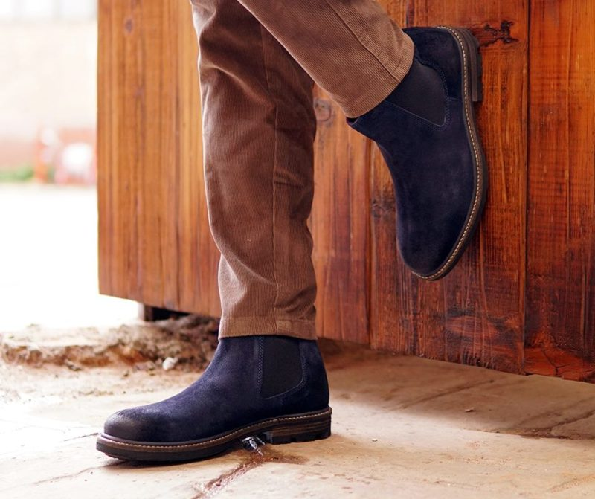
Internationally, Greyder is present in 30 countries with 24 concept stores and 60 concessions. Its franchise network covers markets such as Russia, Iran, Kazakhstan, Uzbekistan, Saudi Arabia, Kosovo, Macedonia, Algeria, Oman, Azerbaijan and Romania.
The chain expands through stores ranging between 90 and 150 sqm in size, located within shopping centers, retail parks, department stores, outlet centers, and on prominent high streets.
Greyder is known for its high quality 100% waterproof footwear that comes in a variety of styles ranging from shoes and boots to sandals and slippers. The company’s products are made using state-of-the-art technologies and undergo a series of tests to make sure they are water resistant. Its collections cater to men and women of all age groups, offering a unique combination of flexibility, style and comfort. In addition to footwear, the brand also markets complementary accessories such as bags, wallets and belts.
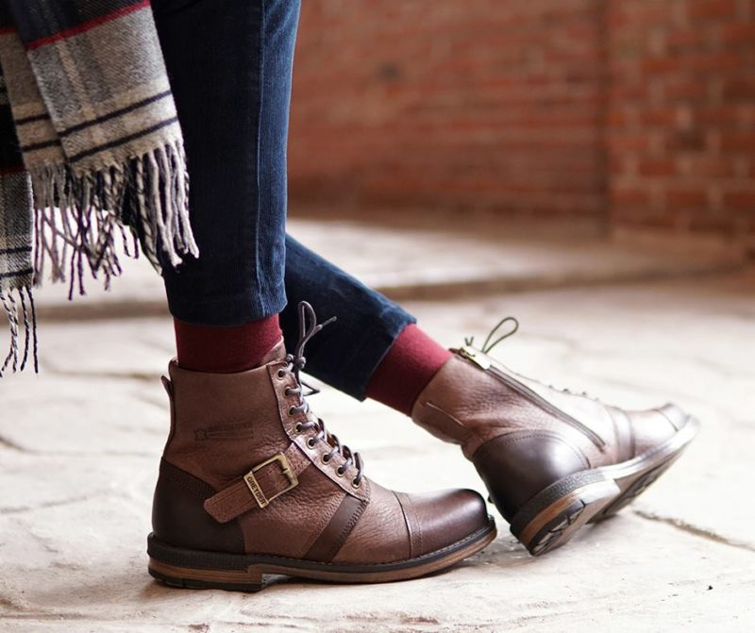
Besides its quality products, Greyder is well know for its large production capacity. The chain produces 2,000,000 pairs of shoes annually and employs 1,400 people in total.
To view Greyder’s full retail assortment visit their www.greyder.com
Take a look at our Company Database page to find more retail companies active in South East Europe region.

